Joel Atkinson
April 3, 2026
CSD440 Server Side Scripting
Assignment 2.2

PHP File Code:
<!-- Joel Atkinson, April 3, 2026. CSD440 Server-Side Scripting Assignment 2.2
The purpose of this assignment is to generate an HTML table using a PHP nested loop structure.
Each cell in the table displays a PHP-generated random number. PHP tags are used only for logic, not for outputting
table tags directly.
-->
<!DOCTYPE html>
<html lang="en">
<head>
<meta charset="UTF-8">
<meta name="viewport" content="width=device-width, initial-scale=1.0">
<title>Joel's PHP Random Number Table</title>
<style>
body {
font-family: Arial, sans-serif;
margin: 0;
}
.banner {
background-color: #663399;
padding: 20px 40px;
}
h1 {
color: #DAA520;
margin: 0;
text-align: center;
}
.divider {
border: none;
border-top: 3px solid #DAA520;
margin: 0;
}
.content {
margin: 40px;
display: flex;
justify-content: center;
}
table {
border-collapse: collapse;
}
th, td {
border: 1px solid #666;
padding: 10px 20px;
text-align: center;
}
th {
background-color: #663399;
color: #DAA520;
}
tr:nth-child(even) {
background-color: #f2f2f2;
}
.info {
text-align: center;
color: black;
margin: 20px 40px 40px;
line-height: 1.8;
}
</style>
</head>
<body>
<div class="banner">
<h1>PHP Random Number Table</h1>
</div>
<hr class="divider">
<div class="content">
<table>
<tr>
<th>Col 1</th>
<th>Col 2</th>
<th>Col 3</th>
<th>Col 4</th>
<th>Col 5</th>
</tr>
<!-- Outer loop iterates over each row -->
<?php for ($row = 0; $row < 5; $row++): ?>
<tr>
<!-- Inner loop iterates over each column in the current row -->
<?php for ($col = 0; $col < 5; $col++): ?>
<td><?php echo rand(1, 100); ?></td>
<?php endfor; ?>
</tr>
<?php endfor; ?>
</table>
</div>
<p class="info">
<strong>Author:</strong> Joel Atkinson<br>
<strong>Course:</strong> CSD 440 - Server-Side Scripting<br>
<strong>Assignment:</strong> 2.2<br>
<strong>Description:</strong> This program uses a PHP nested loop structure to generate a 5x5 HTML table.
Each cell is populated with a random number between 1 and 100 produced by PHP's rand() function.
PHP tags handle only the logic and number output, while all table structure is written in standard HTML.
</p>
</body>
</html>

Screenshot of Output when navigating to localhost/JoelTable2.php:
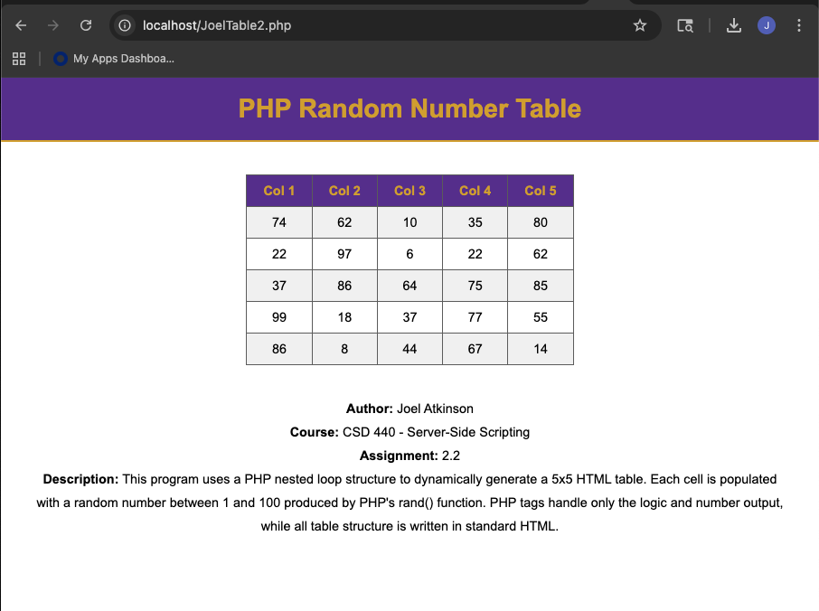
Screenshot of Output again after refreshing, proving that the system is functioning correctly and displaying a new set of randomized numbers:
